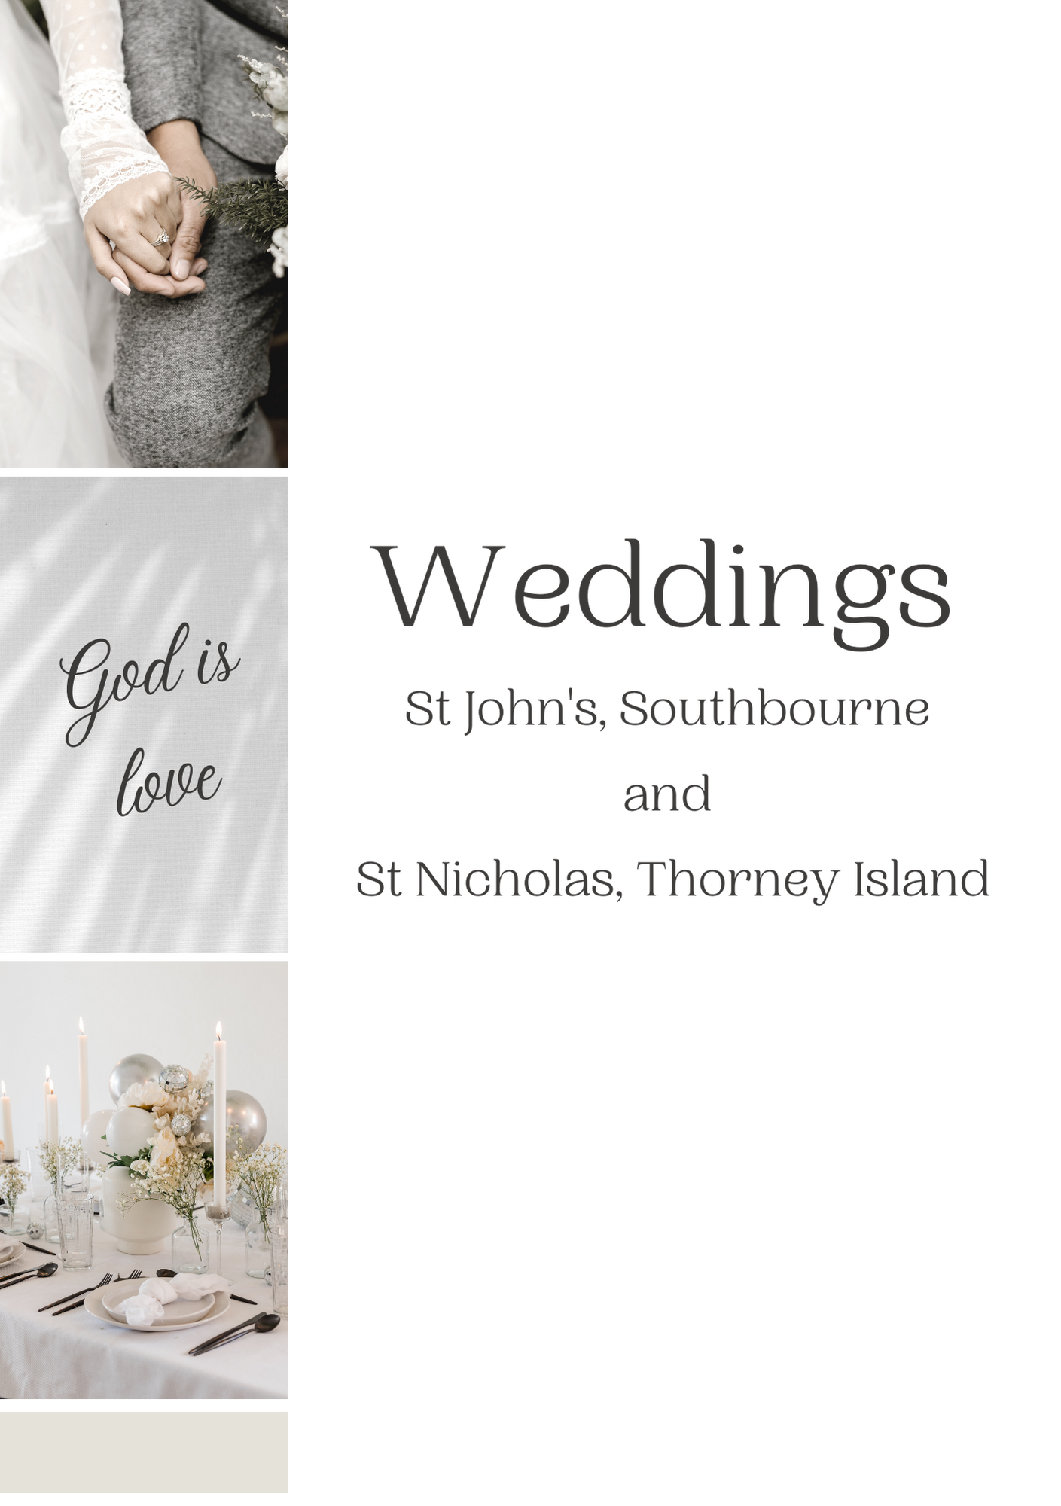
Congratulations if you are planning a wedding!
We love to celebrate with couples and believe that the words of the church's service provide a great entry to married life. You can marry in church whether or not you are baptised and whether or not you’ve been a regular churchgoer. There are legal requirements for couples wishing to get married, these are summarised below, but do ask if you have any questions.

Steps to take at this stage:
- Complete the enquiry form and return it to the Church Office, St John's Church, Southbourne or email it to: admin@stjohnssouthbourne.com
- A member of the clergy will then get in touch to arrange an initial meeting, answer any questions and explain the wedding preparation process.

Legal Requirements for a Qualifying Connection
You can be married here if you are both EEA nationals, are a man and a woman and if either of you have any of the following qualifying connections:
- Live in the Parish (of Southbourne with West Thorney)
- Are on the electoral roll of this Parish
- Has at any time lived in this Parish for at least 6 months
- Has regularly gone to normal church services in St Nicholas or St John’s for a period of at least 6 months
- Was baptised or confirmed in this Parish
- One of your parents has lived in this Parish for at least 6 months
- One of your parents has regularly gone to church services in this Parish for at least 6 months
- One of your parents or grandparents was married in the Parish.

Even if none of these apply, it may sometimes be possible to arrange a special license.The best way to qualify is to join us regularly at our services!
The fees for a Church wedding are set each year by the national Church and vary depending on what you’d like in your wedding. The vicar can give you more information, but it's worth budgeting for around £400-600.
Please return this form to the Church Office. If you have any questions, you can contact us on: 01243 375576 or admin@stjohnssouthbourne.com

All your information is held according to our parish GDPR policy, and only shared with those who need it, i.e. clergy, administrators and treasurers.
Bride & Groom Names
Your Address(es)
Parish where you live (If known)
Contact phone and email
Qualifying Connection
(write ‘none’ if none apply)
Have either of you been married before?
Which church would you like to get married in?
What date and time would you like to get married?
(We’ll try to accommodate you!)

Please tick this box to give consent to your details being added to our Church Management System (this information is stored securely and only available to those involved in the wedding arrangements).
Official Secrets Act & MoD Security
St Nicholas lies within an operational Ministry of Defence Establishment requiring access to St Nicholas to be through areas subject to security protocols and subsequent restrictions on those gaining access to St Nicholas. Weddings must take place under this secure regime, abiding by HM Government, MoD and Church of England regulations that may change on operational circumstances.
Your cooperation and that of your guests in abiding by these security protocols set out in our access notes will ensure experiences at St Nicholas will be happy and memorable for the right reasons.
